Style Guide 1.0

## BRANDING



We are using these 2 logos throughout our website. The name itself speaks for the brand which is Northeastern University. Red color is used to maintain original theme.

## COLORS

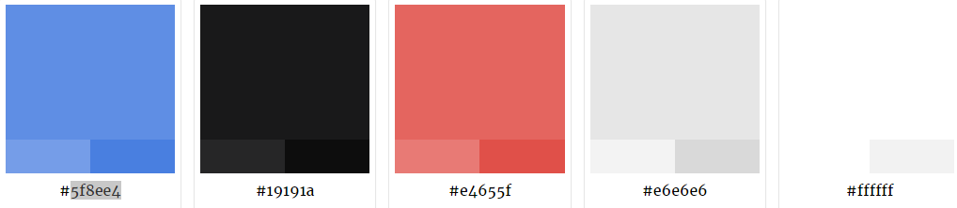

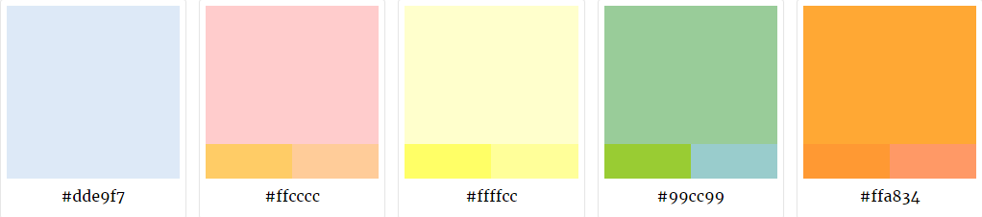

Color Palettes used in the website. Warm colors have been used to depict alerts/important announcements.

## TYPOGRAPHY

|  |
| --- |
| HEADER – Font Arial, Sans-Serif Size 32  SUB-HEADINGS – Font Arial, Sans-Serif Size 26  General Text – Font Arial, Size 16 |

Font type and size specifications implemented in our website.

## BUTTONS

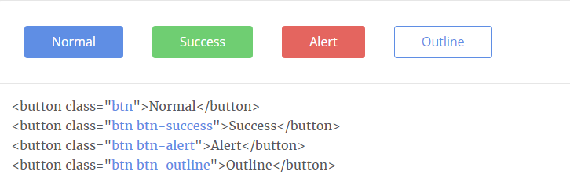

These are few of the buttons (Bootstrap based) used throughout the site.

## ICONS



These are few of the icons used throughout the site. Size has been maintained to 35 x 35 px for control based display such as download button etc.

These are few of the icons used throughout the site. Size has been maintained to 24 x 24 px for integrating within table cells/Form Fields.

## FORM ELEMENTS

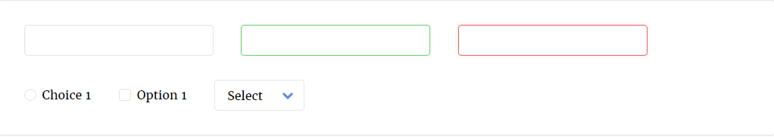

These are the form elements used in our website.